SOLUTION - ACTIVITY 2.1

App.js

import { useState } from "react";

export default *function* App() {

*const* [state, setState] = useState({

    initialized: false,

    productName: null,

    productDescription: null,

    productPrice: null

  });

*let* initializeState = () *=>* {

    setState({

      initialized: true,

      productName: "Rice Krispies",

      productDescription: "a cereal made of popped rice",

      productPrice: "$3.00"

    });

    return state;

  };

*const* str = `The product name is ${state.productName}, product description is ${state.productDescription}, and product price is ${state.productPrice}.`;

  if (state.initialized) {

    return <h1>{str}</h1>;

  } else {

    return (

      <div className="App">

        <button onClick={() *=>* initializeState()}>

          Click here to initialize your state{""}

        </button>

      </div>

    );

  }

}

Sample Output

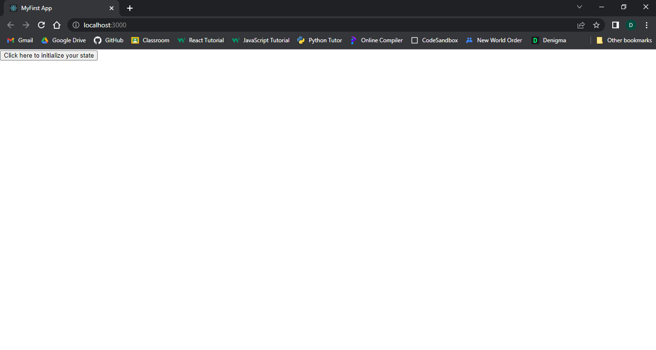

Figure 2.1.1

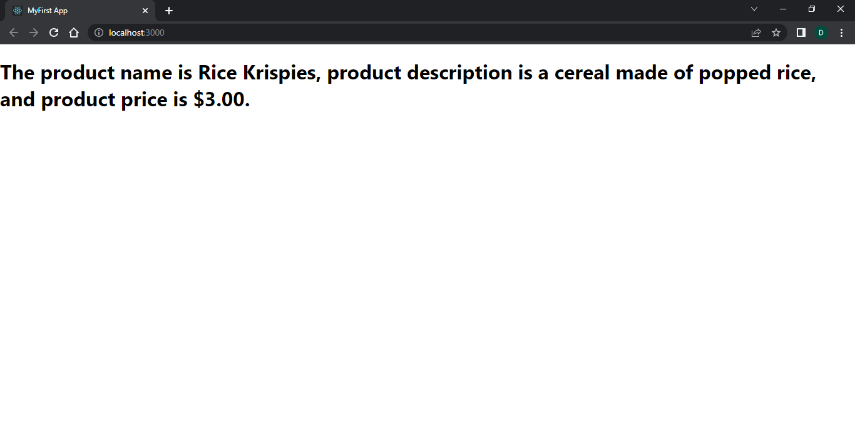

Figure 2.1.2